Import data Mysql to Oozie

Step-1 create table in mysql with Having some data

create table my_trip1

(trip_type varchar(20),starting_place varchar(30),visiting_place varchar(30),

start_date date,end_date date,travelling_mode varchar(30),

interest varchar(30));

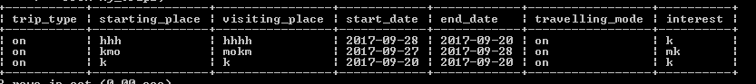

Step-2 create table in H-BASE

create 'trip', ' data',

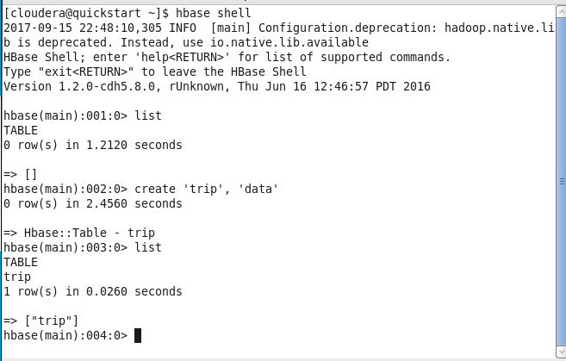

Step -3

Give permission to my-sql database With System IP

grant all privileges on trip1.* to root@192.168.110.1 IDENTIFIED BY 'system' WITH GRANT OPTION;

Step -4 Run Sqoop Job:

sqoop import --connect jdbc:mysql://192.168.110.1/trip1 --username root -P --table my_trip1 --hbase-table trip --column-family trip_detail --hbase-row-key trip_type -m 1

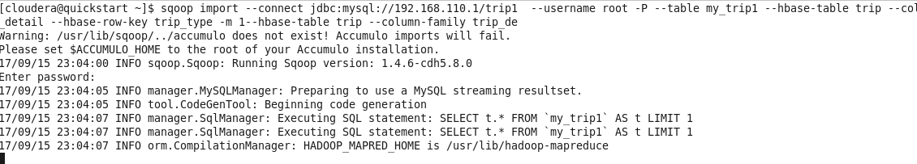

After complete Job:

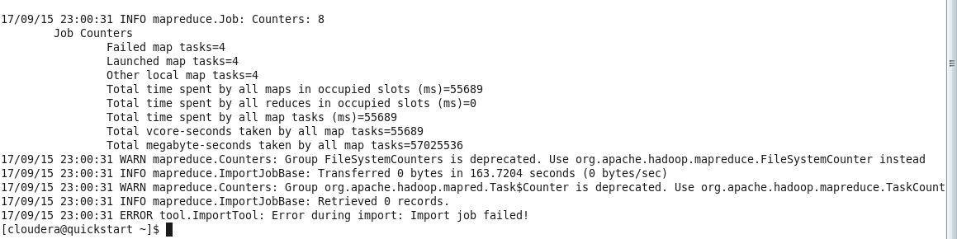



Output:

